UML Diagram & Design Documentation

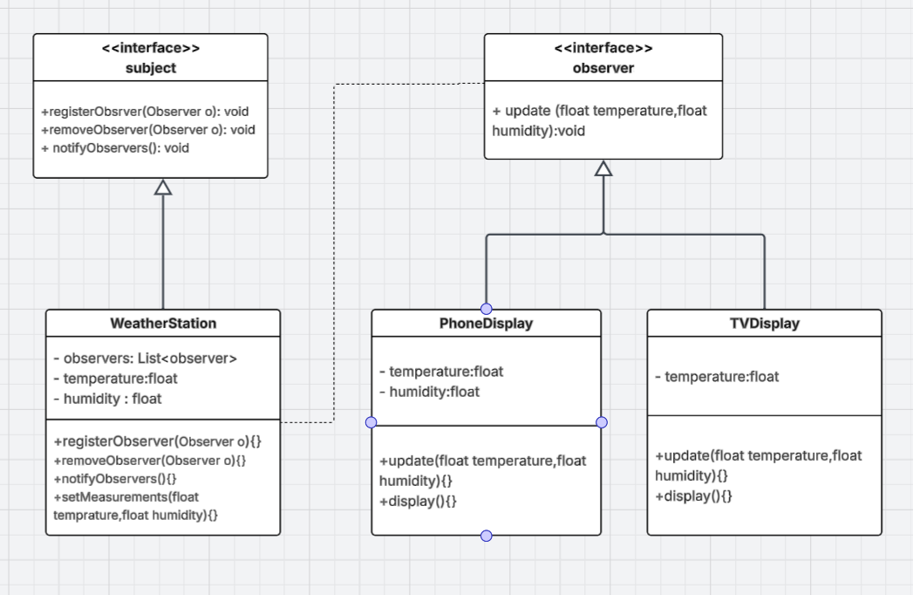

Technical Documentation: Weather Monitoring System (Observer Pattern)

1. Overview
The Weather Monitoring System is designed to provide real-time updates of weather measurements (such as temperature and humidity) to various display devices.
To ensure low coupling and high scalability, the system is engineered using the Observer Design Pattern. This allows new display units to be added or removed dynamically at runtime without altering the core weather tracking logic.

2. Architectural Design & UML Analysis
Based on the provided UML class diagram, the system is structured into two main layers: the Subject (Publisher) and the Observer (Subscriber).

Class Diagram Components:
- <<interface>> Subject: Defines the contract for any object that holds state data and needs to notify dependents. It enforces three vital methods: registerObserver(), removeObserver(), and notifyObservers().

- WeatherStation: The concr (e.g., PhoneDisplay consumes both temperature andete implementation of the Subject. It contains the state variables (temperature, humidity) and maintains a structural list (- observers: List<observer>) to track registered displays.
- <<interface>> observer: Defines the uniform update contract (+ update()) that all listening objects must implement to receive state alterations.

- PhoneDisplay & TVDisplay: Concrete observers that react differently to incoming updates based on their functional scope humidity, while TVDisplay utilizes temperature only).

3. Detailed Component Specification

3.1 Interface: Subject
- Purpose: Contract for registering, unregistering, and notifying observers.
- Methods:
  - + registerObserver(Observer o): void: Appends an observer instance to the notification collection.
  - + removeObserver(Observer o): void: Extracts an observer instance from the notification collection.
  - + notifyObservers(): void: Loops through the observer collection and invokes their respective update() methods.

3.2 Concrete Subject: WeatherStation
- Purpose: Manages and measures meteorological data.
- Attributes:
  - - observers: List<Observer>: Internal collection managing subscribed components.
  - - temperature: float: Stores current temperature value.
  - - humidity: float: Stores current humidity value.
- Methods:
  - + setMeasurements(temperature: float, humidity: float): void: Sets new sensor metrics and immediately triggers notifyObservers().

3.3 Interface: Observer
- Purpose: Standardizes the state-push mechanism.
- Methods:
  - + update(temperature: float, humidity: float): void: Executed by the subject to push state changes.

3.4 Concrete Observers: PhoneDisplay & TVDisplay
- Purpose: Encapsulate presentation logic for the user.
- Methods:
  - + update(...): Coordinates incoming state data with local attributes.
  - + display(): void: Outputs the current data status to the user console interface.

4. Production Code Implementation (Java)
Here is the clean, integrated, and fully functional codebase matching the specifications outlined in the UML architecture:

1. Subject Contract
interface Subject {
void registerObserver(Observer o);
void removeObserver(Observer o);
void notifyObservers();
}

2. Observer Contract

interface Observer {
void update(float temperature, float humidity);
}

3. Concrete Subject (Weather Sensor Core)

class WeatherStation implements Subject {
private List<Observer> observers = new ArrayList<>();
private float temperature;
private float humidity;

@Override
public void registerObserver(Observer o) {
if (o != null && !observers.contains(o)) {
observers.add(o);
}
}

@Override
public void removeObserver(Observer o) {
observers.remove(o);
}

@Override
public void notifyObservers() {
for (Observer observer : observers) {
observer.update(temperature, humidity);
}
}

public void setMeasurements(float temperature, float humidity) {
this.temperature = temperature;
this.humidity = humidity;
notifyObservers(); // Automatic state-push dispatchment
}
}

4. Concrete Observer A: Mobile Application

class PhoneDisplay implements Observer {
private float temperature;
private float humidity;

@Override
public void update(float temperature, float humidity) {
this.temperature = temperature;
this.humidity = humidity;
display();
}

public void display() {
System.out.println("📱 Phone Display -> Temp: " + temperature + "°C | Humidity: " + humidity + "%");
}
}

5. Concrete Observer B: Television Station
class TVDisplay implements Observer {
private float temperature;

@Override
public void update(float temperature, float humidity) {
this.temperature = temperature; // TV ignores humidity metrics
display();
}

public void display() {
System.out.println("📺 TV News Broadcast -> Current Temp: " + temperature + "°C");
{

5. Architectural Benefits & Patterns Analysis
- Loose Coupling (OCP Compliance): The WeatherStation remains completely unaware of the inner mechanics of PhoneDisplay or TVDisplay. It interacts solely through the abstract Observer interface. This satisfies the Open/Closed Principle—the system is open for adding new displays but closed for modifying existing core code.

- Dynamic Subscription Control: Displays can attach or detach themselves dynamically via the reference link drawn between components in the system architecture, preventing resource locks and unnecessary processing allocation.

- One-to-Many Propagation: A single telemetry update within setMeasurements ensures broadcast uniformity across all active subsystems simultaneously, ensuring data consistency.

